Computer Science 102

Group 9 Game Project

Team Members’ roles:

Ntsika Mduba: - Documentation and back end

Pranay Patel: - Back end

Liso Mafu: - Documentation, front and back end

Zolile Sibanda: - Front and back end

Nkululeko Ntakana: - Back end

Hamilton Go - The Game:

Requirements Specification:

Background and Motivation

Hamilton Go is based on the popular and successful Nintendo game - Pokémon. An attacker against an opponent, one versus one. A turn-based battle game with multiple characters to choose from and specialist attacks and abilities. Each player is given a turn to make a move to attack which lowers the opponent’s health points. Some moves can be used to increase one's own health points while others defend against oncoming attacks. The one who loses all of their health first is the loser.

You may ask, don't the rounds become repetitive? In the case that a battle is drawn out, the character gains energy points to unleash a much more powerful attack to end the game or significantly decrease their opponent’s health.

Problem Statement

The idea of a Pokémon based game is challenging. In many aspects the original game is very complex with hundreds of different characters and abilities, but it is not in our team's moral interest to completely rip off the well-known game, producing one far less than the original. As this would show a lack of creativity.

Another issue is being able to create a balanced game. With numerous different characters it is quite difficult to make sure that all the characters are balanced. Not one of them has any ability or power level that is so much greater than the rest of them that it breaks the game and makes it boring. Ensuring that a greater damage by another character - Pikachu - is compensated with a lower health.

Approach

Milestone 1: creating the basic code that will hold and call separate characters

Milestone 2: creating a way for characters to attack and use abilities on each other

Milestone 3: creating code necessary to cycle turn by turn and end game when hp is lost

Milestone 4: creating graphics and guis to support all the previously mentioned code

Milestone 5: creating code to call previously made code in the structure to implement the tournament mode

Milestone 6: creating a simple graphical tutorial for the player to understand how to play the game correctly

Design (architecture of system)

|  |
| --- |
| PokemonGame |
| - playerOneEnergy: int  - playerTwoEnergy: int  - playerOneHealth: int  - playerTwoHealth: int  - playerOneBase: int  - playerTwoBase: int  - playerOneDef: int  - playerTwoDef: int  - playerOneAttacker: Pokemon  - playerTwoAttacker: Pokemon  - playerOneName: String  - playerTwoName: String  - playerOneHealthCount: int  - playerTwoHealthCount: int  - playerOneTurn: boolean  - playerOneCoinChoice: String  - playerTwoCoinChoice: String  - costEnergy: int  - damage: int  - flip: Clip  - layeredPane: JLayeredPane  - bottomLeftPanel: JPanel  - bottomRightPanel: JPanel  - rightSquarePanel: JPanel  - leftSquarePanel: JPanel  - healthValueLeft: JLabel  - healthValueRight: JLabel  - energyValueLeft: JLabel  - energyValueRight: JLabel  - punchButtonLeft: JButton  - kickButtonLeft: JButton  - specialAbilityButtonLeft: JButton  - punchButtonRight: JButton  - kickButtonRight: JButton |  - specialAbilityButtonRight: JButton  - frame: JFrame |
| + addFightingMechanics()  + restartProgram()  + updateButtonStates()  + handleCoinToss() |

Implementation (Important code snippets)

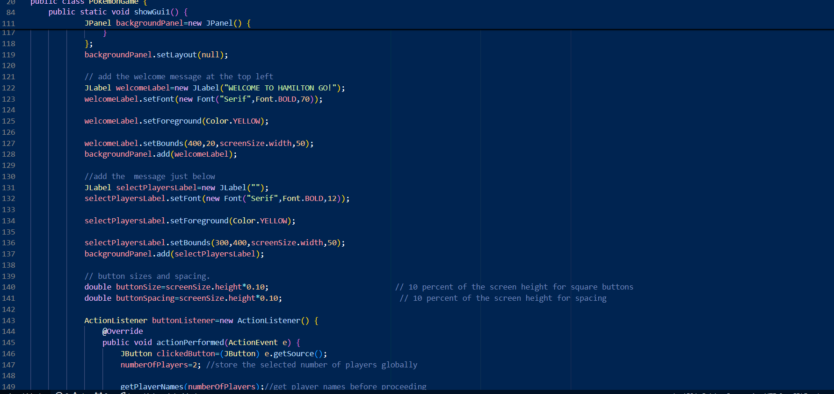

Visual Guide (user tutorials)

* Navigation with front end screenshots

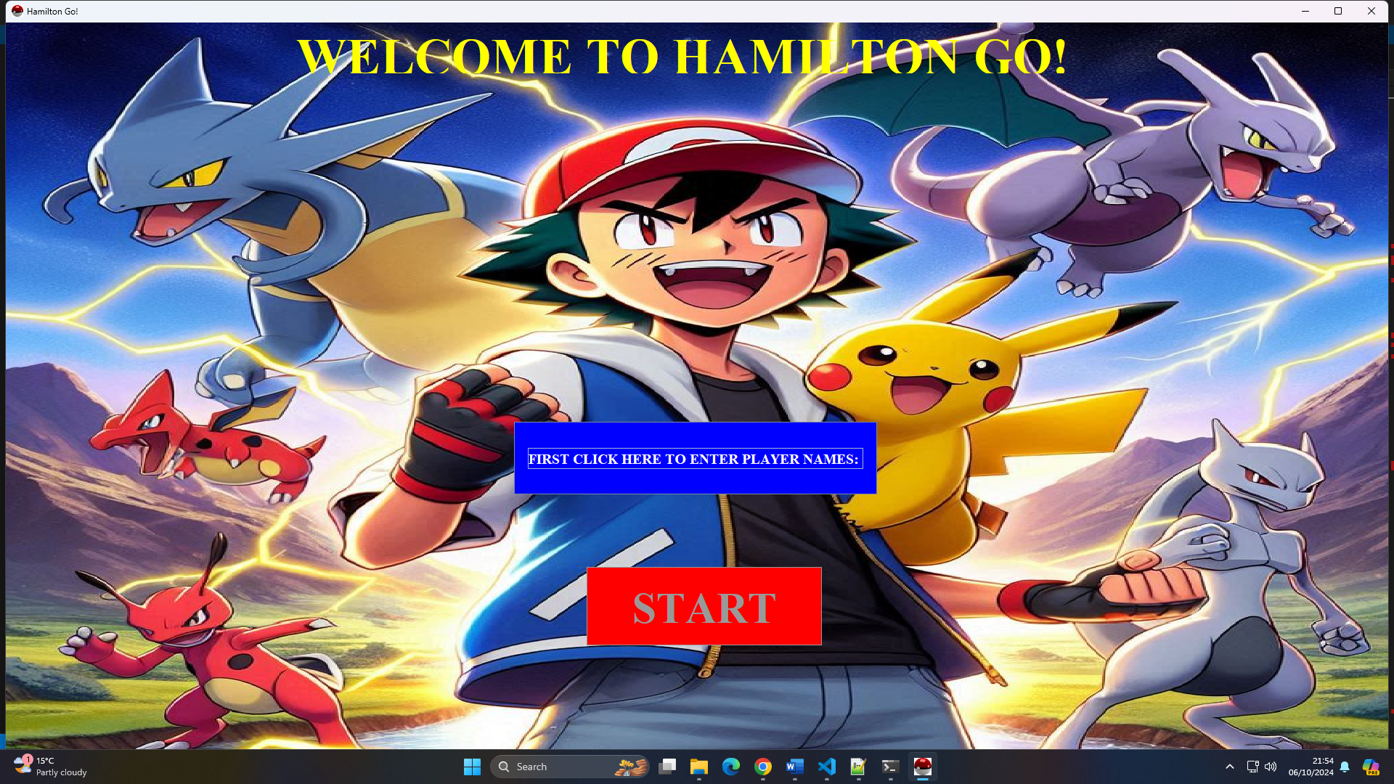

Screenshot 1 [ **Main Menu**]:

* **Header**: WELCOME TO HAMILTON GO!

**Buttons** [ 2]:

1. **FIRST CLICK HERE TO ENTER PLAYER NAME**: this button is to enter player names before to proceed to **START.**

e.g. Player 1 : Liso, Player 2: Nkululeko.

1. **START**: this button starts the game and proceed to another part of the game where you have to choose characters.

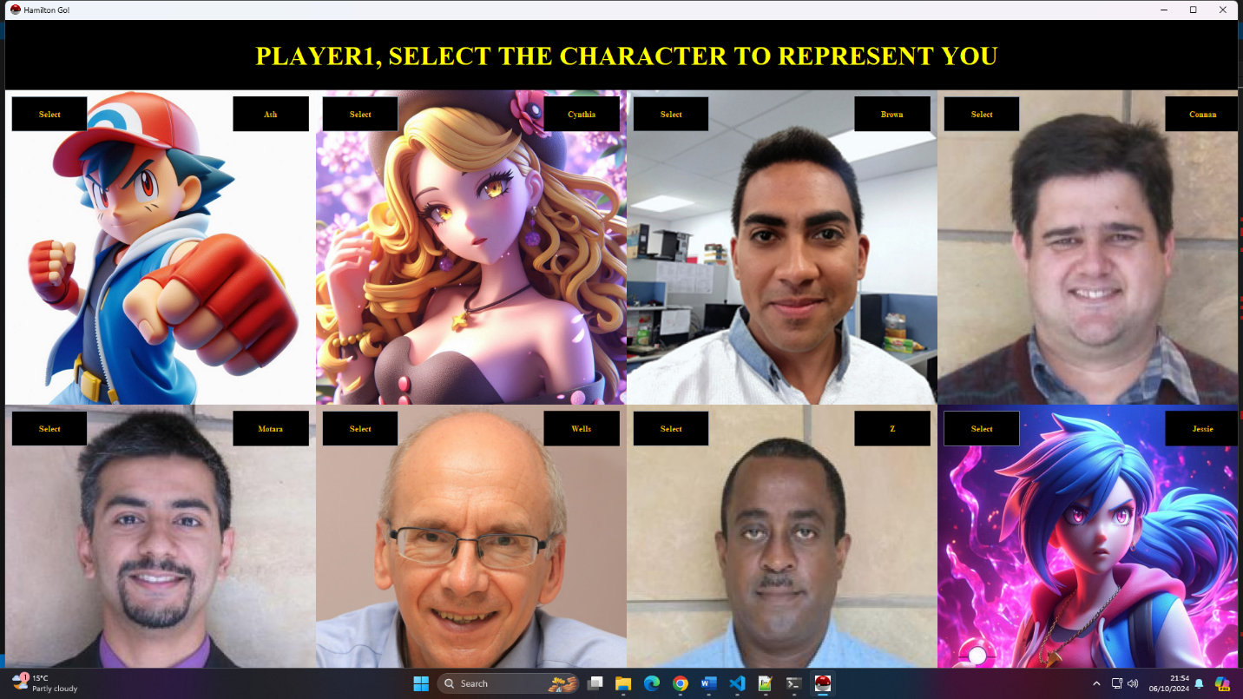

Screenshot 2[**Character selection**]:

* In this panel it’s where player 1 and 2 choose their characters.
* The characters have their names on the top right corner.
* The **SELECT** button allows to choose the character you want.
* After character selection move to Pokémon selection.

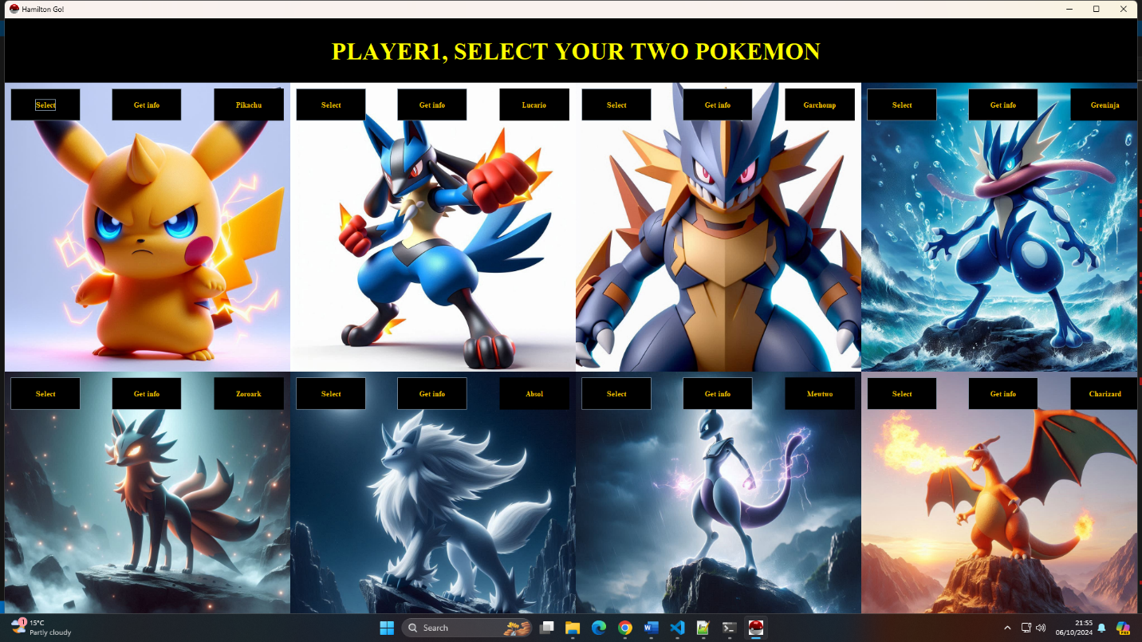

Screenshot3 [**Pokémon selection**]:

* In this panel it’s where player 1 and 2 choose their Pokémon.
* The Pokémon have their names on the top right corner.
* The **SELECT** button allows to choose the Pokémon you want.
* The **Get Info** button shows the stats and the description of the Pokémon.

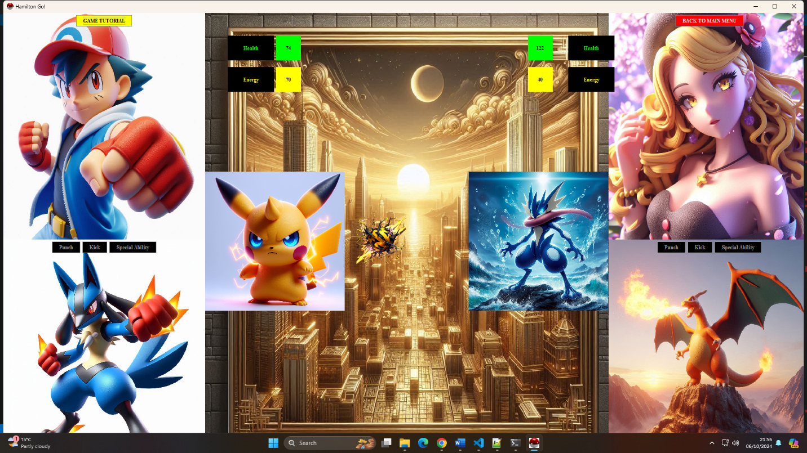

Screenshot 4 [**battleground**]:

* This is where the Pokémon’s fight.
* Before the Pokémon’s fight, the characters do a coin toss where the winner get to attack first.
* **Health bar** [ Black and Green], the health is different for every Pokémon.
* **Energy bar** [ Black and Yellow], the energy is different for every Pokémon.
* Fighting buttons [**Punch, Kick, Special Ability**]
* **Note**: You can only use the kick and special ability buttons at certain energy levels! SO, **PLAY YOUR ATTACKS WISELY**
* Each Pokémon has a different special ability.
* **1 more thing**, don’t forget to **enjoy** the **game**.

HamiltonGo GitHub Repository:

<https://github.com/liso-mafu/HamiltonGo>

References:

<https://technicalwriterhq.com/documentation/software-documentation/how-to-write-software-documentation/>

<https://www.squibler.io/learn/documentation/product-documentation/#:~:text=Product%20documentation%20includes%20all%20technical,on%20the%20latest%20version%20releases.>